# Lesson 36 单词讲解

1. record n. 纪录

set up a new world record hold / keep a record break a record

record-holder off the record 私底下谈论不要记录

v. 纪录，录

1. succeed v. 成功

succeed in sth. / doing sth.

success n. successful adj. successfully adv.

1. intend v. 打算

intend to do sth.

1. solid adj. 固体的，硬的

liquid 液体gas

气体

2 [strong](http://dict.cn/strong.htm) [strɔŋ] a.强壮的

3 [swimmer](http://dict.cn/swimmer.htm)['swimə] n.游泳运动员

[train](http://dict.cn/train.htm)[trein] v.训练

[train](http://dict.cn/train.htm) sb sth

[anxiously](http://dict.cn/anxiously.htm)['æŋkʃəsli] ad.焦急地

**Lesson 36 课文&语法讲解**复习：表示将来的几种方式

非限定性定语从句

1. Debbie Hart is going to swim across the English Channel tomorrow.

Set out 出发 setoff 出发

1. She is going to set out from the French coast at five o'clock in the morning.

确定要去做某事

many people feel that she is sure to succeed.

3.Debbie's father will set out with her in a small boat.

Will be doing 将来进行时

1.Tomorrow he will be watching her anxiously…

as相当于when或者while

时间状语从句一般现在时表示将来

1. Tomorrow he will be watching her anxiously as she swims the long distance to England.

I will tell him the news, when he comes (come) back later. As soon as the plane lands(land), I will let you know.

1. Debbie intends to take short rests every two hours. 6.She will have something to drink ...
2. Most of Debbie's school friends will be waiting for her on the English coast.

Among them will be Debbie's mother… Debbie's mother will be among them…

构成句子必须有动词，Debbie's mother among them… 是不行的，所以得加个动词 be ，will指的是将来时

为什么倒装？

Most of Debbie's school friends will be waiting for her on the English coast.

Among them will be Debbie's mother, who swam the Channel herself when she was a girl.

Among 在。。之间 （多个）between也是在，，之间 （两者）

1. Among them will be Debbie's mother, who swam the Channel herself when she was a girl.

非限定性的定语从句

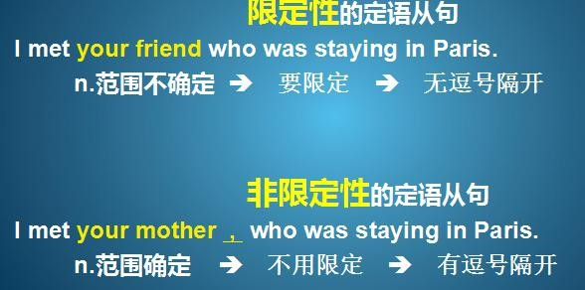

限定／非限定性的定语从句

This is the wall which they built last week. This is the Great Wall ，which is world-famous. 限定／非限定性的定语从句

This is the wall which they built last week.

This is the Great Wall, which is world-famous.

限定／非限定性的定语从句

He came from Beijing ，which is the capital of China.

He came from a city that/which is in the north of China.

限定／非限定性的定语从句

This is the businessman we are cooperating with.

who / whom / that / 省略

This is Bill Gates many people know as the richest man.

, whom

Among them will be Debbie's mother, who swam the Channel herself when she was a girl.

非限定性的定语从句复习：表示将来

一般将来时

将来进行时一般现在时

表示将来的词组非限定性定语从句

# Lesson 36 知识拓展

本课重点:

非限定性定语从句

Among them will be Debbie's mother, who swam the Channel herself when she was a girl.

特殊的 非限定性定语从句

Tony had passed the exam, which surprised us.

They sell the goods in a very low price, which is a bad way to do business.

特殊的 非限定性定语从句

A person’ s early life and its conditions are often the greatest gift to an individual,

which / as any biographer knows.

As any biographer knows, a person ’ s early life and its conditions are often the greatest gift to an individual.

A person’ s early life and its conditions, as any biographer knows, are often the greatest gift to an individual.

